

Paktia University
Compute Science Faculty
Department of Information Systems

Title
(full form of a project title)

Submitted By

Haroon Rasheed

Samiullah Noori

Hamayoun Khaksar

Nayeem Masroor

Supervised By: Mr. Rahmatullah Alikhail

Year: 1405(1447-1448)



Title
(Full form of a project title)

Submitted By

Ahmad

Mahmood

Khan

Akbar

Supervised By: Mr. Rahmatullah Alikhail

Year: 1405 (1447-1448)
FINAL APPROVAL
This is to certify that we have read the project documentation titled “your project title full form name” submitted by the following students of BSc (IS), 8th Semester, as a partial fulfillment of the requirements for the award of the degree of Bachelor of Science in Information Systems.
S.NO | Name | Registration No | Session | Defense Date | Project Marks
1 |  | P09004388 | 1402-1405
2
3
4
It is our judgment that this project documentation meets the required academic standards and is hereby approved for submission to the Department of Information Systems, Faculty of Computer Science, Paktia University.
NO | Committee Members | Signature
1
2
3

Head of Department
Mr. Rahmatullah “Alikhail”

DECLARATION
I hereby declare that this final project is entirely my own work and has been completed independently. To the best of my knowledge, this topic has not been previously researched or submitted by any other student.
The content presented in this project is the result of my personal effort, conducted under the supervision and guidance of the assigned supervisor from the Department of Information Systems, Faculty of Computer Science, Paktia University.
During the preparation of this project, all ethical standards and academic writing guidelines have been strictly followed. Proper citation and academic integrity have been maintained throughout the work.
I understand that any form of plagiarism or academic dishonesty will result in disciplinary action according to university regulations.
- Researcher Name:…………. Sign ( ) Date: / /
- Researcher Name:…………. Sign ( ) Date: / /
- Researcher Name:…………. Sign ( ) Date: / /
- Researcher Name:…………. Sign ( ) Date: / /

ACKNOWLEDGMENT
In the name of Allah, the Most Gracious, the Most Merciful.
First and foremost, I express my deepest and sincerest gratitude to Almighty Allah for granting me health, strength, patience, and knowledge, which enabled me to successfully complete my four-year academic journey and finalize this final year project. Without His endless blessings and guidance, this achievement would not have been possible.
I would like to extend my heartfelt appreciation to my respected parents for their unconditional love, continuous encouragement, and both moral and financial support throughout my academic life. Their sacrifices, prayers, and motivation have always been the strongest foundation of my success. I pray to Almighty Allah to reward them with abundant blessings, good health, and the highest ranks in both this world and the hereafter.
I am profoundly grateful to my honorable supervisor for his invaluable guidance, constructive feedback, patience, and continuous support throughout the preparation of this project. His academic expertise, encouragement, and dedication significantly contributed to the successful completion of this work. I truly appreciate the time and effort he devoted to mentoring me during this research.
I also express my sincere thanks to the Head of the Department, faculty members, and all respected teachers of the Faculty of Computer Science, who provided me with knowledge, guidance, and academic support throughout my studies.
Furthermore, I would like to acknowledge my friends and classmates for their cooperation, motivation, and support during difficult times. Their companionship made my academic journey more meaningful and enjoyable.
Finally, I extend my appreciation to everyone who directly or indirectly contributed to my education and the completion of this project. May Almighty Allah bless them all with success, happiness, and prosperity in both worlds.
Sincerely, [Ahmad”Afghan”, Ali”Akba”, …]

DEDICATION
I dedicate this final year project to my respected parents, whose endless love, sacrifices, and prayers have always been the greatest source of motivation in my life.
I also dedicate this work to my teachers and supervisor, who guided me with their valuable knowledge, support, and encouragement throughout my academic journey.
Finally, I dedicate this achievement to all those who have supported me directly or indirectly in completing my studies.

ABSTRACT
The abstract should provide a concise summary of the entire project and must be written within 150–300 words, ideally fitting on a single page. It should briefly cover the background of the study, the problem being addressed, the proposed solution, the technologies used, the key features of the system, and the expected outcome of the project. The content must be written in formal academic English, using clear, simple, and precise sentences without unnecessary explanations or detailed descriptions.
The abstract should avoid including figures, tables, citations, code, or personal opinions. It should focus only on the main idea of the project and provide a high-level overview rather than detailed chapter information. The writing style should remain professional and objective, using present tense for general facts and past tense for completed work.
At the end of the abstract, it is recommended to include 4–6 relevant keywords that represent the main concepts of the project. Overall, the abstract must be well-structured, concise, and reflect the academic quality of a final year project.

TABLE OF CONTENTS
2. Chpater one 2-8
Introduction 2-7
1.1 Background of the Study 2-7
1.2 Problem Statement 2-8
1.3 Objectives of the Project 2-9
1.4 Scope of the Project 2-11
Examples: 2-12
1.5 Significance of the Project 2-12
1.6 Methodology 2-13
1.7 Tools and Technologies 2-14
1.8 Research Questions 2-15
General Research Question 2-16
Specific Research Questions 2-16
Specific Objective Research Question 2-17
1.9 Organization of the Report 2-17
3. Chapter Two Literature Review 3-19
2.1 Introduction 3-19
2.2 Related Works 3-20
Description 3-21
Strengths 3-21
Weaknesses 3-21
Suggested Format for Related Works 3-22
2.3 Comparative Analysis 3-22
2.4 Research Gap 3-24
2.5 Conclusion 3-25
4. Chapter Tree System Analysis 4-26
3.1 Introduction 4-26
3.2 Existing System Analysis 4-27
3.3 Proposed System 4-28
3.4 Functional Requirements 4-30
3.5 Non-Functional Requirements 4-31
3.6 Feasibility Study 4-33
Technical Feasibility 4-33
Operational Feasibility 4-33
3.7 Requirement Gathering Techniques 4-34
3.8 System Models and Diagrams 4-35
Use Case Diagram 4-35
Activity Diagram 4-36
Sequence Diagram 4-36
Class Diagram 4-36
ER Diagram (Entity Relationship Diagram) 4-36
DFD (Data Flow Diagram) – If Needed 4-37
5. Chapter Four System Design 5-38
4.1 Introduction 5-38
4.2 Architectural Design 5-39
4.3 Database Design 5-40
Tables 5-40
Relationships 5-41
Data Dictionary 5-41
4.4 Interface Design 5-42
4.5 Input Design 5-43
4.6 Output Design 5-44
4.7 Security Design 5-45
6. Chapter Five System Implementation and Testing 6-47
5.1 Introduction 6-47
5.2 Development Environment 6-48
5.3 System Implementation 6-49
5.4 Testing 6-50
Unit Testing 6-51
Integration Testing 6-51
System Testing 6-51
User Acceptance Testing (UAT) 6-52
5.5 Test Cases 6-53

LIST OF TABLES
Table ‎1-1 Students may use table format 2-16
Table ‎2-1 Example Comparative Table 3-24
Table ‎5-1 Suggested Documentation Structure by Pages 6-64

LIST OF FIGURES

Figure ‎5-1 Dashboard 6-65
Figure ‎5-2 use case diagram 6-67
Figure ‎5-3 Data Flow Diagram (DFD) 6-68
Figure ‎5-4 Screen shot of general dashboard 6-69

Chpater one

INTRODUCTION

Chapter outline Chapter objective

- Introduction
- Project Background
- Importance of your project
- Problem statement
- Project Scope

After going through this Chapter, you will be able to:
• To explain the background and significance of your project.
• To identify the limitations of the traditional paper-based system.
• To describe the purpose and scope of the proposed system.

Introduction
This chapter introduces the project topic, explains the background of the study, identifies the existing problems, and presents the objectives, scope, significance, methodology, and research questions of the project. It provides the foundation for understanding the proposed system and its importance in solving real-world problems.
Students should write this chapter using clear, formal, and academic language. The chapter should logically introduce the project and clearly explain why the proposed system is needed.

1.1 Background of the Study
Writing Guidelines
This section provides a general overview of the project domain and explains its importance in real-world applications. Students should introduce the system area within the context of Information Systems and describe the current situation in organizations, institutions, or businesses where the problem exists.
The background should:
- Introduce the project topic clearly
- Explain the importance of the system domain
- Describe current practices and technologies
- Discuss existing challenges or limitations
- Explain why the proposed system is necessary
- Relate the project to modern technological developments
Students should gradually move:
- From general discussion
- To specific organizational or system-related issues
Students may include:
- Statistical information
- Organizational challenges
- Technology trends
- Real-world examples
Students should avoid:
- Writing unrelated historical details
- Providing solutions in this section
- Copy-pasting from internet sources
- Writing very broad or unclear explanations

1.2 Problem Statement
Writing Guidelines
This section clearly identifies the main problems in the existing system or process. Students should explain the difficulties, inefficiencies, and limitations faced by users or organizations.
The problem statement should:
Clearly define the current problem
- Explain why the problem exists
- Describe the impact of the problem
- Identify gaps in the existing system
- Justify the need for the proposed solution
Students should focus on problems such as:
- Manual operations
- Data redundancy
- Slow processing
- Human errors
- Poor security
- Lack of automation
- Difficulty in report generation
Students should ensure that:
- Problems are realistic and specific
- Statements are directly related to the proposed project
- The section logically leads to the project objectives
Students should avoid:
- Providing detailed solutions
- Writing vague or emotional statements
- Mentioning unrelated organizational issues

1.3 Objectives of the Project
Writing Guidelines
This section defines the goals and expected outcomes of the project. Objectives should clearly explain what the project aims to achieve.
Students should divide objectives into:
- General Objective
- Specific Objectives
General Objective
The general objective represents the overall goal of the project and should summarize the main purpose of developing the system.
Example:
To design and develop an efficient and automated information system that improves organizational processes and data management.
Specific Objectives
Specific objectives explain the detailed tasks and achievements of the project. These objectives should:
- Be clear and measurable
- Start with action verbs
- Be directly related to the problem statement
Examples of action verbs:
- Design
- Develop
- Implement
- Improve
- Automate
- Generate
- Analyze
- Enhance
Example Specific Objectives:
1. To automate manual processes within the organization.
2. To improve data accuracy and management.
3. To enhance system security and access control.
4. To reduce time and operational effort.
5. To generate accurate and efficient reports.
Important Guideline
The objectives and research questions must match each other logically.
Each research question should have a corresponding project objective.
Example:
Research Question Matching Objective
What are the problems in the existing system? To analyze the existing system problems
How can automation improve operations? To automate manual processes
How can security be improved? To enhance system security
Students should avoid:
  - Writing objectives that are too broad
  - Including implementation details
  - Writing objectives unrelated to the project problem

1.4 Scope of the Project
Writing Guidelines
This section defines the boundaries and limitations of the proposed system. Students should clearly explain what the system will include and what it will not include.
The scope should specify:
  - System modules
  - Functionalities
  - Users of the system
  - Organizational boundaries
  - Technical limitations
Students should explain:
  - Features included in the system
  - Features excluded from the project
  - Operational limitations
  - Project constraints (limitation)

Examples:
  - The system will support student registration and report generation.
  - The system will not support mobile application integration in the current version.
Students should avoid:
  - Writing unrealistic scope
  - Making the project more broad
  - Leaving scope undefined

1.5 Significance of the Project
Writing Guidelines
This section explains the importance and benefits of the project for users, organizations, management, students, or society.
Students should explain:
  - How the system improves existing processes
  - Benefits of automation
  - Improvements in efficiency and accuracy
  - Reduction of manual workload
  - Better decision-making support
  - Improved data management and security
The significance should clearly identify:
  - Beneficiaries of the system
  - Organizational value
  - Academic or technical contribution
Students should avoid:
  - Repeating objectives only
  - Writing general statements without explanation

1.6 Methodology
Writing Guidelines
This section describes the development methodology used to build the system. Students should explain the selected methodology and why it is appropriate for the project.
Common methodologies include:
  - Waterfall Model
  - Agile Model
  - Prototype Model
Students should explain:
  - Planning phase
  - Analysis phase
  - Design phase
  - Implementation phase
  - Testing phase
  - Deployment phase (if applicable)
Students may include:
  - Methodology diagrams
  - Development process flowcharts
Students should justify:
  - Why the selected methodology is suitable for the project
Students should avoid:
  - Mentioning methodology names without explanation
  - Mixing multiple methodologies unnecessarily

1.7 Tools and Technologies
Writing Guidelines
This section lists and explains the tools and technologies used during system development.
Students should mention:
  - Programming languages
  - Frameworks
  - Database systems
  - Development tools
  - Design tools
  - Testing tools
Examples include:
  - PHP
  - Java
  - Python
  - Laravel
  - Flutter
  - MySQL
  - Firebase
  - Visual Studio Code
  - XAMPP
Students should explain:
  - Purpose of each technology
  - Why the technology was selected
Table ‎1-1 Students may use table format
Tool/Technology | Purpose
PHP | Backend development
MySQL | Database management
Bootstrap | User interface design

Students should avoid:
  - Listing unused technologies
  - Mentioning tools without explanation

1.8 Research Questions
Writing Guidelines
This section presents the questions that guide the research, analysis, and development of the project. Research questions should be directly derived from the problem statement and aligned with the project objectives.
Students should include:
  - One General Research Question
  - Multiple Specific Research Questions

General Research Question
The general research question represents the overall investigation focus of the project.
Example:
How can an automated information system improve organizational efficiency, data management, and operational performance?

Specific Research Questions
Specific research questions should focus on detailed project issues and expected solutions.
Example:
- What are the main problems in the existing system?
- How can the proposed system improve current processes?
- What technologies are suitable for developing the system?
- How does the system improve efficiency and data management?
- What benefits will the system provide to users and organizations?
Important Guideline
Research questions must directly correspond to the project objectives.
Example Alignment

Specific Objective Research Question
To automate manual processes How can the proposed system automate current operations?
To improve data management How does the system improve data accuracy and management?
To enhance system security What security improvements does the system provide?
Students should avoid:
  - Writing unrelated questions
  - Using vague or unclear wording
  - Including questions not addressed in the project

1.9 Organization of the Report
Writing Guidelines
This section briefly explains the structure of the entire project documentation. Students should summarize the contents of each chapter in paragraph form.
The section should explain:
  - Chapter One: Introduction
  - Chapter Two: Literature Review
  - Chapter Three: System Analysis
  - Chapter Four: System Design
  - Chapter Five: System Implementation and Testing
  - Chapter Six: Conclusion and Recommendations
Students should briefly describe the purpose of each chapter.
Students should avoid:
  - Writing excessive details
  - Repeating full chapter contents

Chapter Two Literature Review
This chapter reviews and analyzes previous studies, existing systems, research papers, and related technologies associated with the project topic. The purpose of the literature review is to understand existing solutions, identify their strengths and weaknesses, and determine the research gap that justifies the development of the proposed system.
Students should critically analyze related works instead of only describing them. The chapter should demonstrate academic research skills and proper understanding of the project domain.

2.1 Introduction
Writing Guidelines
This section provides an overview of the literature review chapter and explains its purpose in the research and system development process.
Students should briefly explain:
- The importance of reviewing previous studies and systems
- The purpose of analyzing related works
- How the literature review supports the proposed project
- The main topics covered in this chapter
The introduction should mention:
- Related works
- Comparative analysis
- Research gap identification
Students should avoid:
- Detailed discussion of related systems
- Repeating information from Chapter 1

2.2 Related Works
Writing Guidelines
This section reviews previous systems, research papers, applications, websites, or technologies related to the proposed project. Students should analyze and summarize existing studies and explain their relevance to the current project.
Students should review at least:
- 5–10 related systems or research studies for undergraduate projects
The reviewed works may include:
- Research papers
- Existing software systems
- Web applications
- Mobile applications
- Information systems
- Academic journals
- Conference papers
For each related work, students should include:
Title
Write the full title of the research paper, system, or application.
Author
Mention the author(s) or organization responsible for the work.
Year
Mention the publication or development year.

Description
Briefly explain:
- Purpose of the system/research
- Main functionalities
- Technologies used
- Target users

Strengths
Explain the positive aspects of the system, such as:
- Good performance
- User-friendly interface
- Security features
- Automation capabilities
- Fast processing

Weaknesses
Explain the limitations or problems of the system, such as:
- Limited functionality
- Poor user interface
- Security issues
- Lack of scalability
- Slow performance
Students should:
- Critically analyze each work
- Use academic and reliable sources
- Write in their own words
- Properly cite all references
Students should avoid:
- Copy-pasting from articles or websites
- Listing systems without analysis
- Using unrelated research works
- Writing very short descriptions

Suggested Format for Related Works
Related Work 1
- Title:
- Author:
- Year:
- Description:
- Strengths:
- Weaknesses:
Students may also present related works in table format if appropriate.

2.3 Comparative Analysis
Writing Guidelines
This section compares the reviewed systems or studies to identify similarities, differences, strengths, and limitations.
Students should prepare a comparison table between existing systems based on important features and characteristics.
Comparison criteria may include:
- Technology used
- Security
- User friendliness
- Automation
- Reporting functionality
- Search functionality
- Platform support
- Performance
- Scalability
Table ‎2-1 Example Comparative Table
Feature | System A | System B | Proposed System
Login System | Yes | Yes | Yes
Report Generation | Limited | Yes | Advanced
Mobile Support | No | Yes | Yes
Security | Medium | High | High
Students should:
- Clearly explain the comparison
- Highlight advantages of the proposed system
- Use meaningful comparison criteria
Students should avoid:
- Very large or confusing tables
- Comparing unrelated systems
- Writing comparison without explanation

2.4 Research Gap
Writing Guidelines
This section identifies the limitations, missing features, or unresolved problems found in existing systems and research studies. The research gap explains why the proposed system is necessary.
Students should explain:
- What existing systems fail to provide
- Problems still faced by users
- Missing features or limitations
- Areas requiring improvement
The research gap should clearly justify:
- Why the proposed project is important
- How the proposed system improves current solutions
Examples of research gaps:
- Lack of automation
- Weak security mechanisms
- Poor user interface
- Absence of mobile support
- Slow performance
- Limited reporting features
- No real-time processing
Students should avoid:
- Writing general statements without evidence
- Repeating weaknesses from previous sections only
- Claiming unrealistic innovations

2.5 Conclusion
Writing Guidelines
This section summarizes the major findings of the literature review chapter. Students should briefly explain what was learned from the reviewed studies and how the literature review supports the proposed project.
The conclusion should:
- Summarize key observations from related works
- Highlight common strengths and weaknesses
- Restate the identified research gap
- Explain the importance of the proposed system
Students should avoid:
- Introducing new information
- Repeating full descriptions of previous systems
- Writing very long paragraphs

Chapter Tree System Analysis
This chapter analyzes the current system, identifies existing problems and requirements, and explains the proposed solution. It focuses on understanding how the system should function before the design and implementation phases begin. The chapter should clearly demonstrate the project requirements, feasibility, and system behavior using proper analysis techniques and diagrams.
Students should write this chapter using clear technical and academic language while maintaining logical organization and consistency.

3.1 Introduction
Writing Guidelines
This section provides an overview of the system analysis chapter and explains the importance of system analysis in software development.
Students should briefly explain:
- The purpose of system analysis
- The importance of identifying user requirements
- The need to study the existing system
- The role of analysis in developing an effective system
The introduction should summarize the major sections included in this chapter, such as:
- Existing system analysis
- Proposed system
- Requirements analysis
- Feasibility study
- System diagrams and models
Students should avoid:
- Detailed explanations of later sections
- Repeating information from Chapter 1

3.2 Existing System Analysis
Writing Guidelines
This section explains the current system or process being used before the proposed system is developed. Students should analyze how the existing system operates and identify its strengths and weaknesses.
Students should clearly describe:
- Current workflow or manual process
- Existing technologies or tools used
- Problems faced by users
- Limitations of the current system
The explanation may include:
- Data handling methods
- Report generation process
- Communication methods
- Record management process
- Advantages of the Existing System
Students should mention positive aspects of the current system, such as:
- Simplicity
- Familiarity among users
- Low initial cost
- Easy manual operation
- Disadvantages of the Existing System
Students should explain system limitations and problems, such as:
- Time consumption
- Data redundancy
- Human errors
- Poor security
- Difficult report generation
- Lack of automation
- Data loss risks
Students should provide real examples whenever possible.
Students should avoid:
- Giving only disadvantages without explanation
- Writing emotional or unrealistic statements
- Providing unrelated organizational information

3.3 Proposed System
Writing Guidelines
This section explains the new system that will be developed to solve the identified problems. Students should clearly describe how the proposed system improves the existing system.
Students should explain:
- Purpose of the proposed system
- Main functionalities
- System workflow
- Technologies used
- User interaction process
The explanation should focus on:
- Automation
- Accuracy
- Security
- Efficiency
- Ease of use
- Advantages of the Proposed System
Students should explain improvements such as:
- Faster processing
- Improved data management
- Better security
- Reduced manual work
- Automated reporting
- Increased efficiency
- Better user experience
- Features of the Proposed System
Students should list and explain important features, such as:
- User Login System
- Data Management
- Search Functionality
- Report Generation
- Notifications
- User Roles and Permissions
- Dashboard
Students should avoid:
- Writing implementation details
- Including source code
- Repeating requirement lists without explanation

3.4 Functional Requirements
Writing Guidelines
Functional requirements describe the services, operations, and functions that the system must perform.
Students should explain each functionality separately and clearly.
Examples include:
- Login
- Registration
- Report Generation
- Search
- Data Entry
- User Management
- Notification System
For each functional requirement, students should describe:
- Input
- Process
- Output
- Example
- Login Function
- Input: Username and password
- Process: Validate user credentials
- Output: Access to dashboard or error message
Students should:
- Use numbered or categorized requirements
- Focus on user and system interactions
- Keep explanations simple and clear
Students should avoid:
- Mixing technical coding details
- Combining multiple functions into one unclear description

3.5 Non-Functional Requirements
Writing Guidelines
Non-functional requirements define the quality standards and operational characteristics of the system.
Students should explain system qualities such as:
- Security
- Performance
- Reliability
- Usability
- Scalability
- Maintainability
- Availability
- Security
Students should explain:
- User authentication
- Password protection
- Access control
- Data protection methods
- Performance
Students should explain:
- System response time
- Speed of operations
- Efficiency under workload
- Reliability
Students should explain:
- System stability
- Error handling
- Backup and recovery mechanisms
- Usability
Students should explain:
- Ease of use
- User-friendly interfaces
- Navigation simplicity
Students should avoid:
- Very short generic statements
- Writing theoretical definitions only

3.6 Feasibility Study
Writing Guidelines
This section evaluates whether the proposed system is practical and achievable. Students should explain different types of feasibility analysis related to the project.

Technical Feasibility
Students should explain:
- Availability of required technologies
- Hardware and software requirements
- Technical skills needed
- System compatibility
- Economic Feasibility
Students should analyze:
- Estimated project cost
- Hardware/software expenses
- Maintenance cost
- Cost-benefit considerations
Students may include simple cost estimation tables.

Operational Feasibility
Students should explain:
- User acceptance
- Organizational readiness
- Ease of system operation
- Staff training requirements
Students should avoid:
- Unrealistic budget estimations
- Overly theoretical explanations
- Ignoring project limitations

3.7 Requirement Gathering Techniques
Writing Guidelines
This section explains how information and system requirements were collected from users, organizations, or stakeholders.
Students should describe the techniques used for collecting data and requirements.
Common techniques include:
- Interview
Students should explain:
- Who was interviewed
- Purpose of the interview
- Type of information collected
- Observation
Students should explain:
- Processes observed
- User activities monitored
- Existing workflow analysis
- Questionnaire
Students should explain:
- Types of questions prepared
- Target respondents
- Purpose of the questionnaire
Students may include:
- Sample questionnaires
- Data collection summaries
Students should avoid:
- Mentioning techniques not actually used
- Giving very short explanations

3.8 System Models and Diagrams
Writing Guidelines
This section presents graphical models and diagrams used to represent system structure, behavior, and data flow. Diagrams help explain the system visually and improve understanding of system operations.
Students should ensure that:
All diagrams are clear and properly labeled
Diagram elements are readable
Diagrams match the actual system requirements
The following diagrams may be included:

Use Case Diagram
Shows interactions between users and the system.
Students should include:
- Actors
- System functionalities
- User interactions

Activity Diagram
Shows workflow and process flow within the system.
Students should explain:
- Activity sequence
- Decision points
- Process flow

Sequence Diagram
Shows communication between system objects over time.
Students should explain:
- Message flow
- User-system interaction sequence

Class Diagram
Represents system classes, attributes, methods, and relationships.
Students should include:
- Classes
- Attributes
- Methods
- Relationships

ER Diagram (Entity Relationship Diagram)
Shows database entities and relationships.
Students should include:
- Entities
- Primary keys
- Relationships

DFD (Data Flow Diagram) – If Needed
Represents the movement of data within the system.
Students should include:
- External entities
- Processes
- Data stores
- Data flows
Students should avoid:
- Using copied diagrams from the internet
- Including unreadable or incomplete diagrams
- Adding diagrams without explanation

Chapter Four System Design
This chapter describes the overall design of the proposed system. It explains how the system components are structured, how users interact with the system, how data is organized and processed, and how security mechanisms are implemented. The purpose of this chapter is to provide a detailed blueprint of the system before implementation.
Students should present the system design clearly using diagrams, tables, screenshots, and proper technical explanations. The chapter should remain organized, professional, and directly related to the developed system.

4.1 Introduction
Writing Guidelines
This section provides a brief overview of the system design chapter and explains the importance of system design in software development.
Students should briefly explain:
- The purpose of system design
- The transition from analysis to design
- Major design components included in the chapter
- The importance of designing an efficient, secure, and user-friendly system
The introduction may mention:
- Architectural design
- Database design
- Interface design
- Input and output design
- Security design
Students should avoid:
- Detailed explanations of each section
- Repeating previous chapter content

4.2 Architectural Design
Writing Guidelines
This section explains the overall structure and architecture of the system. Students should describe how different system components interact with each other and how data flows within the system.
Students should clearly explain the selected architecture model, such as:
- 3-Tier Architecture
- Client-Server Architecture
- Web-Based Architecture
- Mobile Application Architecture
- Cloud-Based Architecture
The explanation should include:
- Presentation Layer
- Business Logic Layer
- Database Layer
- User interaction flow
- Communication between components
Students should include:
- Architecture diagrams
- Component interaction diagrams
- System workflow illustrations
Example:
In a 3-Tier Architecture:
- Presentation Layer → User Interface
- Business Logic Layer → System Processing
- Database Layer → Data Storage
Students should explain why the selected architecture is suitable for the project.
Students should avoid:
- Using diagrams without explanation
- Copying architecture diagrams from the internet
- Including unrelated technical details

4.3 Database Design
Writing Guidelines
This section explains how data is stored, organized, and managed within the system. Students should present the database structure clearly and logically.
The section should include:

Tables
Students should describe all important database tables used in the system.
For each table, include:
- Table Name
- Purpose
- Attributes/Fields
- Primary Key
- Foreign Key

Relationships
Students should explain the relationships between database tables.
Relationship types may include:
- One-to-One
- One-to-Many
- Many-to-Many
Students should include:
- Entity Relationship Diagram (ERD)
- Relationship explanations
- Data flow descriptions

Data Dictionary
Students should provide a detailed data dictionary describing all database fields.
The data dictionary should include:
- Field Name
- Data Type
- Size
- Description
- Constraints

Students should avoid:
- Missing table relationships
- Unclear database diagrams
- Inconsistent field naming

4.4 Interface Design
Writing Guidelines
This section explains the visual appearance and layout of the system interfaces. Students should describe how users interact with the system through screens, pages, and forms.
Students should include:
- Login pages
- Dashboard pages
- Data entry forms
- Report pages
- Navigation menus
- Admin panels
For each interface:
- Explain its purpose
- Describe major functionalities
- Include screenshots or UI mockups
Students should focus on:
- User friendliness
- Simplicity
- Accessibility
- Navigation ease
- Consistency of design
Students should avoid:
- Low-quality screenshots
- Unorganized layouts
- Excessive design details unrelated to functionality

4.5 Input Design
Writing Guidelines
This section explains how data is entered into the system and how user inputs are validated and processed.
Students should describe:
- Input forms
- Data entry methods
- Validation rules
- Required fields
- Error handling mechanisms
Students should explain:
- Input accuracy measures
- Data validation techniques
- User guidance during data entry
Examples:
- Registration forms
- Search forms
- Update forms
- Login forms
Validation examples:
- Required field validation
- Email format validation
- Password strength validation
- Numeric field restrictions
Students should avoid:
- Ignoring validation mechanisms
- Providing screenshots without explanation
- Including implementation code unnecessarily

4.6 Output Design
Writing Guidelines
This section explains the outputs generated by the system and how information is presented to users.
Outputs may include:
- Reports
- Notifications
- Dashboards
- Printed documents
- Search results
- Statistical summaries
Students should explain:
- Output format
- Information presentation
- Report generation process
- Output readability and usability
Students should include:
- Sample reports
- Output screenshots
- Generated summaries
Students should focus on:
- Clarity
- Accuracy
- User readability
- Professional presentation
Students should avoid:
- Unnecessary screenshots
- Repetitive report samples
- Outputs unrelated to system functionality

4.7 Security Design
Writing Guidelines
This section explains the security mechanisms implemented to protect the system, data, and users.
Students should describe:
- Authentication mechanisms
- Authorization and access control
- Password security
- Data protection methods
- Backup and recovery strategies
- Session management
- Input validation for security
Examples of security measures:
- Username and password authentication
- Role-based access control
- Encrypted passwords
- SQL Injection prevention
- Form validation
- Secure database access
Students may also explain:
- Firewall usage
- HTTPS communication
- Activity logging
- User permissions
Students should avoid:
- Mentioning security features not implemented
- Writing general security theory only
- Ignoring practical security measures

Chapter Five System Implementation and Testing
This chapter explains how the proposed system was developed, implemented, and tested. It describes the development environment, implemented modules, testing procedures, test cases, and system screenshots. The chapter should clearly demonstrate that the system functions correctly according to the project requirements.
Students should write this chapter in a clear, technical, and professional academic style while avoiding unnecessary theoretical explanations.

5.1 Introduction
Writing Guidelines
This section provides a brief overview of the implementation and testing phase of the project. Students should explain the purpose of this chapter and summarize the activities performed during system development and testing.
The introduction should briefly mention:
- System implementation process
- Development environment
- Testing methods used
- Importance of testing for system quality and reliability
- Students should avoid:
- Repeating information from previous chapters
- Providing detailed technical explanations in this section

5.2 Development Environment
Writing Guidelines
This section describes the hardware and software environment used during system development and testing. Students should clearly mention all technologies, tools, frameworks, and platforms used to build and run the system.
The section should include:
Hardware Requirements
Examples:
- Processor
- RAM
- Storage
- Internet connection
- Server specifications
- Software Requirements
Examples:
- Operating System
- Programming Language
- Frameworks
- Database Management System
- IDE or Code Editor
- Browser
- Testing Tools
Students may present the information in table format.
Example Table
Component | Specification
Operating System | Windows 11
Programming Language | PHP
Database | MySQL
Web Server | XAMPP
IDE | Visual Studio Code
Students should avoid:
- Listing unnecessary software
- Providing incomplete specifications
- Mentioning technologies not used in the project
Note: this kind of tables will not acceptable in documentation

5.3 System Implementation
Writing Guidelines
This section explains how the system was developed and implemented. Students should describe the major modules and functionalities developed in the system.
Students should:
- Explain each module separately
- Describe system workflow
- Explain how modules interact with each other
- Mention important features implemented
- Describe database integration and functionality
Common modules may include:
- User Authentication Module
- Student Management Module
- Report Generation Module
- Search Module
- Admin Dashboard
- Notification System
For each module, students should explain:
- Purpose of the module
- Main functionalities
- Inputs and outputs
- User interactions
Students may include:
- Flowcharts
- Module diagrams
- Short code snippets if necessary
- Students should avoid:
- Including large source code blocks
- Explaining programming syntax in detail
- Repeating design chapter information

5.4 Testing
Writing Guidelines
This section explains the testing procedures performed to verify that the system works correctly and satisfies user requirements. Students should describe the different testing methods used and explain their purpose and results.
The following testing types should be explained:

Unit Testing
Guideline
Unit testing verifies individual modules or functions independently.
Students should:
- Test each module separately
- Verify functionality correctness
- Mention tools or methods used
Examples:
- Login validation
- Data insertion
- Search functionality

Integration Testing
Guideline
Integration testing verifies whether multiple modules work together correctly.
Students should explain:
- Interaction between modules
- Data flow between components
- Integration issues encountered
Examples:
- Login module connected with dashboard
- Database connected with report generation

System Testing
Guideline
System testing evaluates the complete system as a whole.
Students should verify:
- Overall system performance
- Functional correctness
- Security
- Reliability
- Navigation flow
Students may mention:
- Error handling
- Response time
- Compatibility testing

User Acceptance Testing (UAT)
Guideline
User Acceptance Testing verifies whether the system satisfies end-user requirements.
Students should:
- Explain who tested the system
- Describe user feedback
- Mention whether the system met user expectations
Examples:
- Staff testing
- Student testing
- Administrator testing
- Students should avoid:
- Writing testing theory only
- Mentioning testing methods without results
- Ignoring failed tests or issues

5.5 Test Cases
Writing Guidelines
This section presents detailed test cases used to verify system functionality. Students should provide organized test case tables showing system inputs, expected outputs, actual outputs, and testing status.
Each test case should include:
- Test Case ID
- Module Name
- Input
- Expected Result
- Actual Result
- Status (Pass/Fail)
Example Test Case Table
Test Case ID | Module | Input | Expected Result | Actual Result | Status
TC-01 | Login | Valid username/password | User logs into dashboard | Successful login | Pass
TC-02 | Registration | Empty fields | Validation message displayed | Validation shown | Pass
Students should:
- Include important system functionalities
- Use realistic test data
- Clearly identify test outcomes
Students should avoid:
- Incomplete test cases
- Unrealistic inputs
- Missing results or status fields
5.6 System Screenshots
Writing Guidelines
This section contains screenshots of the developed system demonstrating the implemented functionalities and user interfaces.
Students should include screenshots of:
- Login Page
- Dashboard
- Main Modules
- Forms
- Reports
- Search Functions
- User Management Pages
- System Outputs
Each screenshot should:
- Be clear and readable
- Have a figure number
- Include a caption or description
- Be explained briefly in the text
Example
Figure 5.1: Login Page
This page allows authorized users to access the system using valid credentials.
Students should avoid:
- Blurry screenshots
- Excessive or unnecessary images
- Unorganized screenshot placement
- Screenshots without explanation

Chapter 6: Conclusion and Recommendations
This chapter presents the final summary of the project, highlights the overall achievements, and provides recommendations and future directions related to the developed system. It should clearly demonstrate how the project objectives were achieved and explain possible improvements for future development. The chapter must be written in a clear, concise, and professional academic style without introducing new technical details or unnecessary explanations.
6.1 Conclusion
Writing Guidelines
This section provides a brief summary of the entire project and explains the overall outcome of the developed system. Students should restate the project problem, objectives, methodology, and major achievements of the system.
The conclusion should:
- Summarize the main purpose of the project
- Highlight the major functionalities implemented
- Explain how the project objectives were achieved
- Describe the benefits of the developed system
- Mention the overall success of the project
- Reflect the importance of the system in solving the identified problem
- Students may also briefly mention:
- Technologies used
- Testing results
- User benefits
- System performance
- Students should avoid:
- Introducing new topics or requirements
- Adding detailed explanations or diagrams
- Repeating entire chapters
- Including references, tables, or screenshots
- The writing should remain concise, logical, and objective.
6.2 Recommendations
Writing Guidelines
This section presents suggestions and recommendations for improving the system, organizational processes, or implementation environment. Recommendations should be realistic, practical, and related to the project findings.
Students should:
- Suggest improvements for system performance and usability
- Recommend better technologies or security mechanisms if needed
- Mention training or maintenance requirements
- Provide suggestions for organizations or future developers
- Recommend ways to improve data management and efficiency
- Examples of recommendations:
- Improve system security using advanced authentication methods
- Add backup and recovery mechanisms
- Develop mobile application support
- Integrate online payment or notification services
- Enhance system scalability for larger organizations
Students should avoid:
- Unrealistic or unrelated recommendations
- Repeating conclusions
- Writing very short or vague statements
6.3 Future Work
Writing Guidelines
This section explains additional features, modules, or enhancements that can be implemented in the future to further improve the system. Future work should focus on features that were not implemented due to limitations such as time, resources, or technical constraints.
Students should:
- Identify possible future enhancements
- Mention advanced technologies that can be integrated later
- Explain additional modules or functionalities
- Suggest system expansion possibilities
Examples:
- Mobile application development
- Artificial Intelligence integration
- Cloud-based deployment
- Multi-language support
- Online reporting dashboards
- Biometric authentication
- Real-time notifications
- Data analytics and visualization features
Students should clearly explain how these future enhancements can improve the overall system.
Students should avoid:
- Repeating implemented features
- Mentioning impossible or unrelated ideas
- Writing incomplete points without explanation
References
Writing Guidelines
This section contains all sources of information, research materials, books, articles, journals, websites, and other references used during the preparation of the project documentation and system development. Proper referencing ensures academic integrity and helps avoid plagiarism.
Students must use a standard academic citation style consistently throughout the documentation. The department may approve one of the following citation styles:
- APA (American Psychological Association)
Students should:
- Cite all external sources used in the project
- Include only references that are actually cited in the documentation
- Arrange references properly according to the selected citation style
- Ensure consistency in formatting
- Use reliable and academic sources whenever possible
Recommended sources include:
- Books
- Research papers
- Journals
- Conference papers
- Official documentation
- Academic websites
- Technical manuals
- Students should avoid:
- Using unreliable or non-academic websites only
- Missing citations for copied information
- Mixing multiple citation styles
- Incomplete reference information
- Minimum recommended references:
- 10–20 references for undergraduate projects
Example of APA Style
Book Reference
Author Last Name, First Initial. (Year). Book Title. Publisher.
Example:
Stallings, W. (2018). Database Systems. Pearson Education.
Website Reference
Author/Organization. (Year). Title of webpage. URL
Example:
Oracle. (2024). MySQL Documentation. https://dev.mysql.com/doc/

Appendices
Writing Guidelines
The appendices section includes supplementary materials that support the project but are not included in the main chapters. These materials provide additional technical, operational, or research-related information relevant to the project.
Appendices should be properly organized and labeled clearly, such as:
- Appendix A
- Appendix B
- Appendix C
Possible appendices may include:
- Source Code
- Questionnaire Forms
- User Manual
- Installation Guide
- System Configuration
- Additional Reports
- Extra Screenshots
- Sample Outputs
- Test Results
- Database Scripts
Students should:
- Include only relevant supporting materials
- Organize appendices properly
- Add titles and descriptions for each appendix
- Ensure readability and formatting consistency
- Students should avoid:
- Adding unnecessary or unrelated materials
- Including large raw code without formatting
- Repeating information already explained in the main chapters

User Manual
Writing Guidelines
The User Manual provides a practical guide explaining how to use the developed system. It should help users understand system operations step-by-step without requiring technical knowledge.
The manual should be written in simple, clear, and user-friendly language.
The User Manual should include:
- System introduction
- System requirements
- Installation instructions
- Login procedure
- Description of menus and modules
- Step-by-step system usage
- Screenshots of important pages
- Instructions for performing major tasks
- Logout procedure
- Students should provide clear operational steps for:
- User registration
- Login
- Data entry
- Searching records
- Updating information
- Generating reports
- System administration functions
Each step should:
- Be numbered sequentially
- Include screenshots where necessary
- Contain brief explanations
Example:
Step 1: Login to the System
- Open the system in the web browser.
- Enter username and password.
- Click the Login button.
- The dashboard page will appear successfully.
- Students should avoid:
- Using complex technical terminology
- Skipping important operational steps
- Including unclear screenshots
- Writing long unnecessary explanations
The User Manual should enable end users to operate the system easily and independently.
Table ‎5-1 Suggested Documentation Structure by Pages
Section | Approx. Pages
Chapter 1 | 10–15
Chapter 2 | 15–20
Chapter 3 | 15–25
Chapter 4 | 15–25
Chapter 5 | 15–20
Chapter 6 | 5–10
Total | 70–120

Note: Caption of tables must be at the top of the table and caption of figures must be at the end of the picture

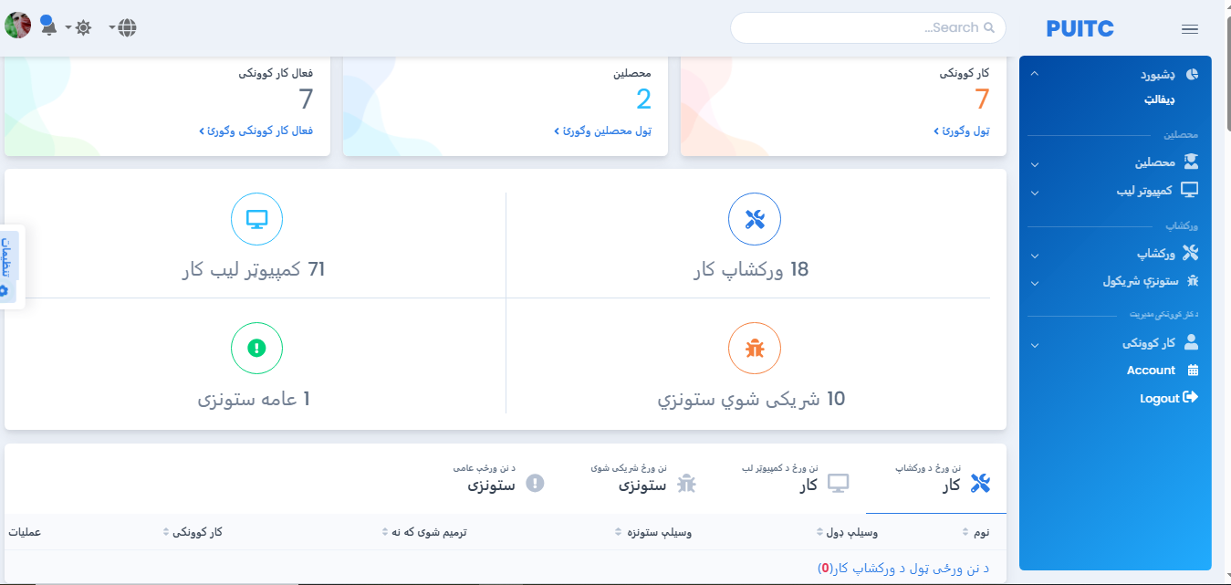
Figure ‎5-1 Dashboard

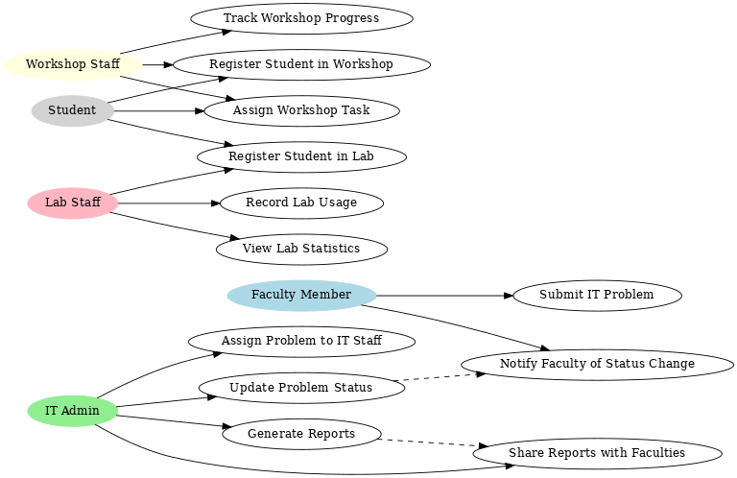
Figure ‎5-2 use case diagram
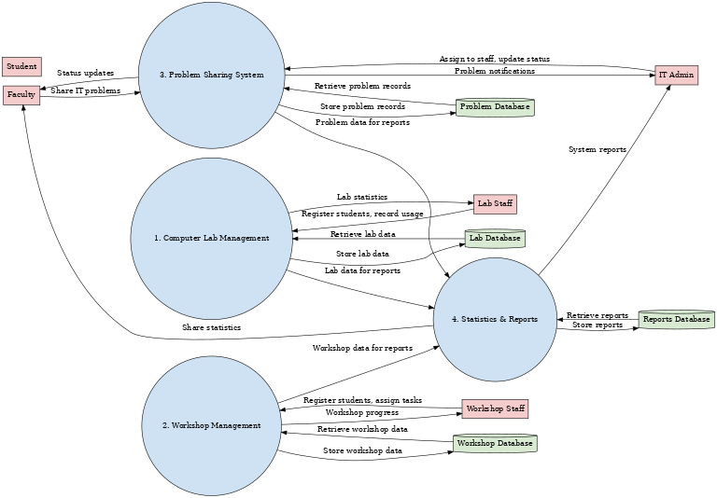
Figure ‎5-3 Data Flow Diagram (DFD)
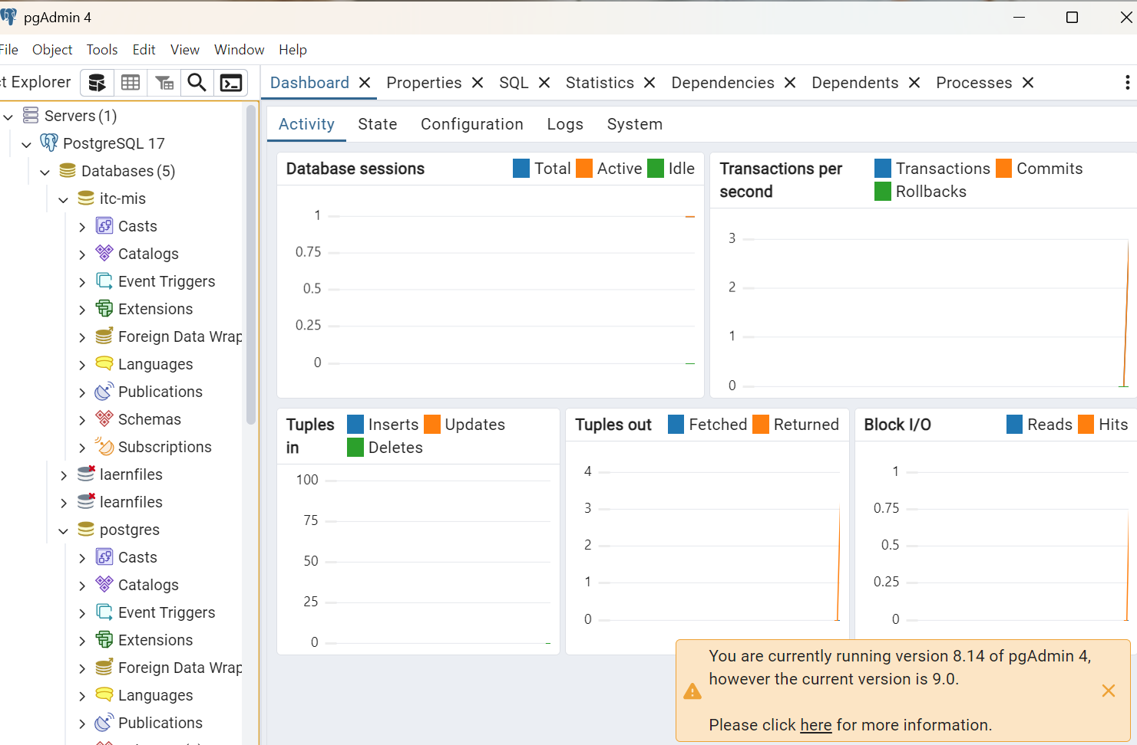
Figure ‎5-4 Screen shot of general dashboard

لنډیز
دلته باید تاسو د خپلې پروژې (Abstract) ملي ژبې ته وژباړۍ بغیر له کمولو او زیاتولو څخه


پکتیا پوهنتون
کمپیوټر ساینس پوهنځی
معلوماتي سیستمونو څانګه

ستاسو د پروژې بشپړ نوم

چمتوکوونکي

احمد
محمود
خان
اکبر

لارښود استاد: پوهنیار رحمت الله علی خیل
کال:۱۴۰۵(۱۴۴۷-۱۴۴۸)





پکتیا پوهنتون
کمپیوټر ساینس پوهنځی
معلوماتي سیستمونو څانګه

ستاسو د پروژې بشپړ نوم

چمتوکوونکي
احمد
محمود
خان
اکبر

لارښود استاد :پوهنیار رحمت الله علی خیل

کال: ۱۴۰۵(۱۴۴۸-۱۴۴۷)

